  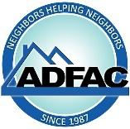    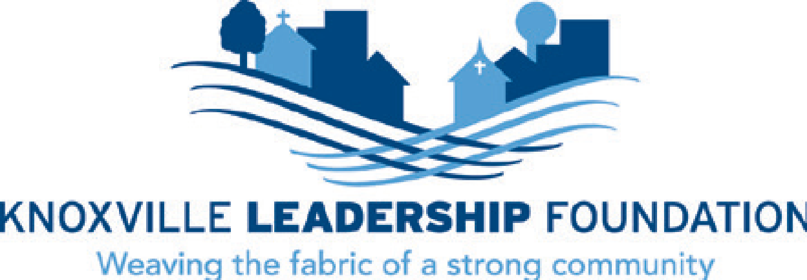  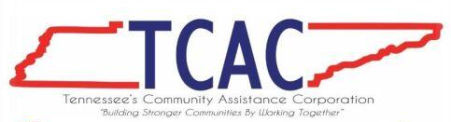 | November 14, 2024  The Fahe Tennessee Caucus congratulates you on your successful campaign for the US House of Representatives.  Fahe is a Treasury-certified Community Development Financial Institution and Network of over 50 nonprofit housing entities building thriving communities in Appalachia.  The Fahe Tennessee Caucus consists of 16 Member organizations across Appalachian Tennessee.  Together, our Caucus works to address Tennessee’s housing needs by channeling state, federal, and private investments to produce housing families can afford, while also driving community economic development and addressing homelessness. In a state that has produced only 6 new housing units for every 10 jobs created in the last decade, this work is vitally important.  Should you be interested in learning more about Tennessee’s housing needs, or about how our work “works,” our Caucus stands ready to assist. We look forward to collaborating with you throughout your upcoming term to deepen our impact and bring safe, attainable housing to revitalized communities across the state.  Any inquiries about our housing, homelessness, and community development work may be directed to Maria Catron, TN Caucus Chair, mcatron@orha.net , or Maggie Riden with the Fahe Advocacy Team at mriden@fahe.org  Sincerely,  Maria Catron  Maria Catron,  Executive Director Oak Ridge Housing & Redevelopment Authority  Tennessee Caucus Chair  On Behalf Of:  Aid to Distressed Families of Appalachian Counties (ADFAC)  Appalachia Habitat for Humanity  Appalachia Service Project  Blount County Habitat for Humanity  Clinch-Powell RC&D Council  Creative Compassion, Inc.  Crossville Housing Authority  Eastern Eight Community Development  Foothills Community Development  HomeSource east tennessee  Kingsport Housing and Redevelopment Authority  Knoxville Leadership Foundation  Loudon County Habitat for Humanity  Mountain T.O.P.  Oak Ridge Housing Authority  TN Community Assistance Corporation

