Team Morrisey  P.O. Box 11903  Charleston, WV 25339  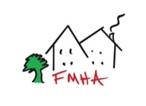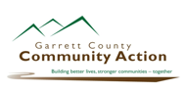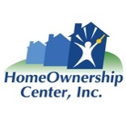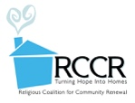 | November 14, 2024  Dear Governor Elect Morrisey,  On behalf of NAME OF ORG and The Fahe West Virginia Caucus, we congratulate you on your successful campaign for the Governor of West Virginia.  Fahe is a Treasury-certified Community Development Financial Institution and Network of over 50 nonprofit housing entities building thriving communities in Appalachia. The Fahe WV Caucus consists of 10 Member organizations across West Virginia and one based in Garrett County, Maryland.  BLURB ON YOUR SPECIFIC IMPACT  Together, our Caucus works to address West Virginia’s housing needs by channeling state, federal, and private investments to produce housing families can afford, while also driving community economic development and addressing homelessness. In a state that ranks 46th in new home construction per capita despite a growing economy and workforce, this work is vitally important.  Should you be interested in learning more about West Virginia’s housing needs, or about how our work “works,” our Caucus stands ready to assist.  We look forward to collaborating with you throughout your upcoming term to deepen our impact and bring safe, attainable housing to revitalized communities across the state.  Any inquiries about our housing, homelessness, and community development work may be directed to NAME OF ORG AND EMAIL or, Kevin Jones, WV Caucus Chair, at kjones@rccr.org.  Sincerely,  On behalf of:  Almost Heaven Habitat for Humanity  Coalfield Development Corp.  Fairmont-Morgantown Housing Authority  Garrett Co. Community Action Committee  HomeOwnership Center  Housing Authority of Mingo County  Mon Valley Habitat for Humanity  North Central West Virginia Community Action Association  Randolph County Housing Authority  Religious Coalition for Community Renewal  Southern Appalachian Labor School  Woodlands Development and Lending

